Research Protocol
Tracking touch: Touch predictions reflected in pupil dilation

Updated: September 2, 2026 (Cohort 2)
C. de Witte, I. de Vicente, T. Couprie, L. Miller, O. Colizoli

1. Preparation
- Pick up lab key room MM 00.478 (Physiology lab)
- Get relevant forms out of locker in participant waiting room - Locker 5
- Turn on electricity in lab (green button)
- Turn light in experiment (participant) room to level 3.
- Turn on stimulus/experiment (EXP) computer (middle computer)
- Turn on EyeLink computer (right-hand-side computer), make sure it’s in EyeLink mode not Windows mode.
- Get headphones and put new headphone covers on.
- Set up materials:
o Forms (get from locker):
- Research protocol
- Informed consent
- Screening form
- Participant list for payment
- Questionnaire
o Open PsychoPy v.2024.2.4 from Desktop, scripts (from local D drive: D:/Users/Olympia/experiment2):
- EyeLink setup: eyelink_setup.py
- Practice: touch_prediction_PRACTICE_version2.py
- Experiment: touch_prediction_version2.py
  - If they are not present for any reason, they can be downloaded from: https://github.com/colizoli/tracking_touch_exp2
- Open Lime Survey in computer (link in online protocol and text file in D:/Users/Olympia/tracking_touch_exp2/experiment2)
o Extra (inside closet in experiment room):
- Pillow for hand rest
- Make-up remover (in case participant is wearing mascara)
o Extra check: Is everything connected?

o Solenoid Control (pictures below):
- Connect solenoids into ports 1, 2, and 3 (see tape on solenoid box)
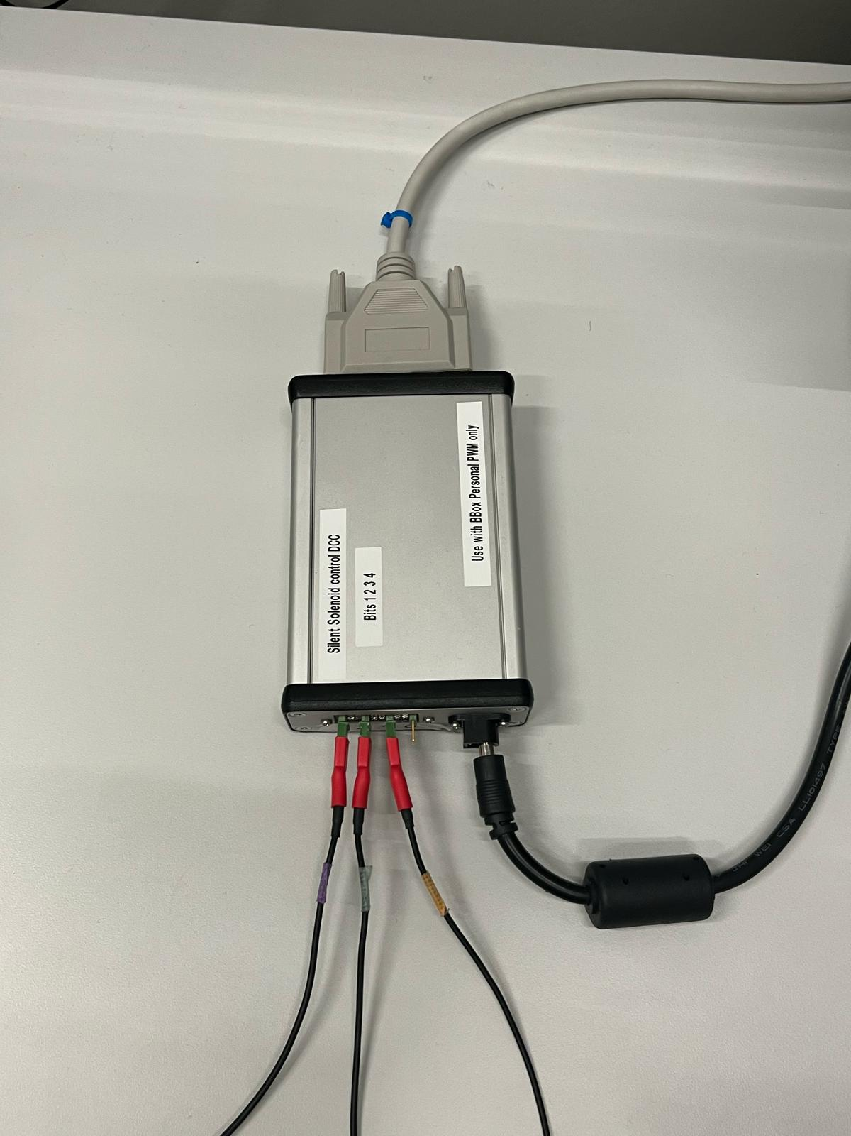
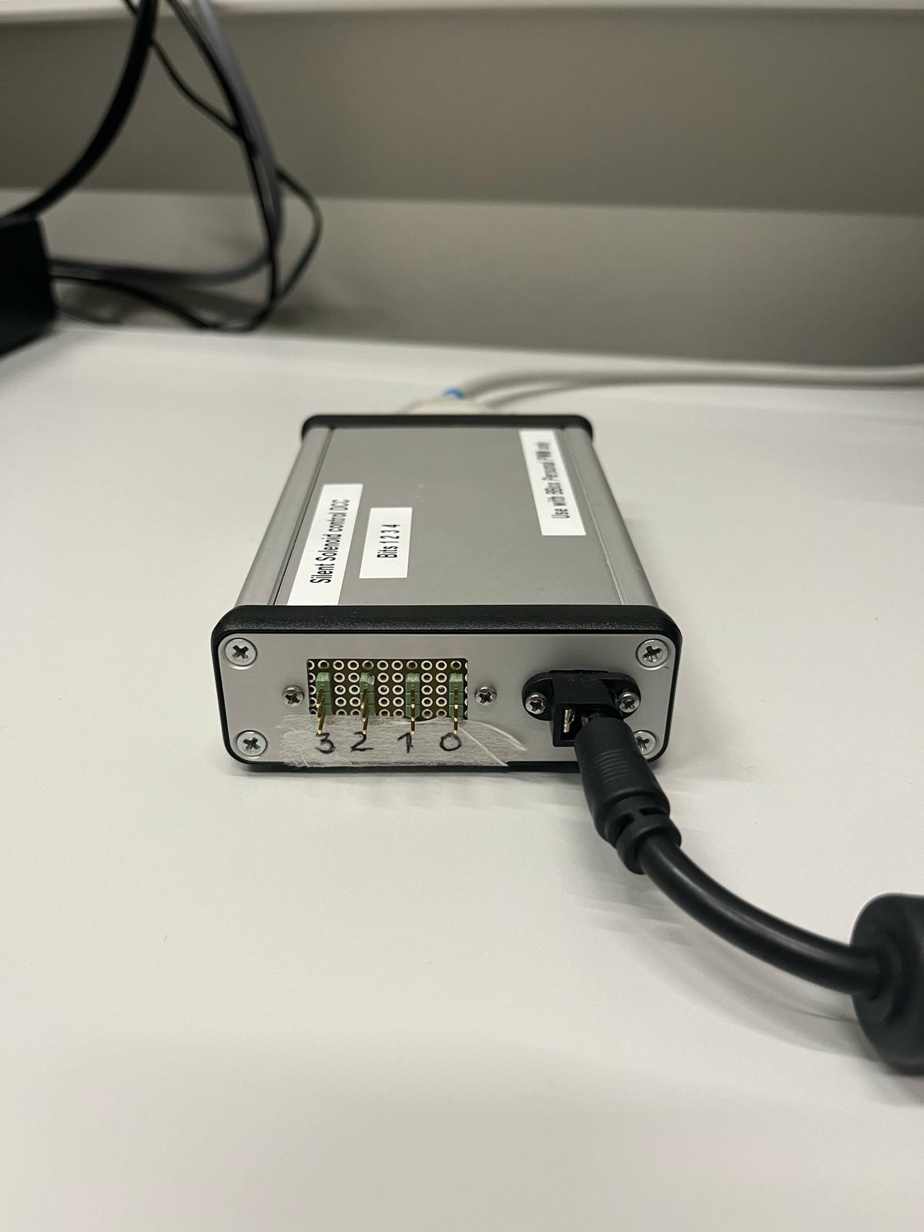

o Eye tracker:
- In the experiment room, plug in the power cable to the eye-tracker
- Take off the lens cap
- Turn on the computer of the eye tracker, choose EYELINK mode, not Windows
- Put chin rest directly in front of the chair, with solenoids stimulators on the left hand side
- (If needed) Check the EyeLink setup options and configuration (see photos below). Make sure in “Set Configuration” it is in “Desktop > Stabilized Head > Monocular > 35 mm” mode.
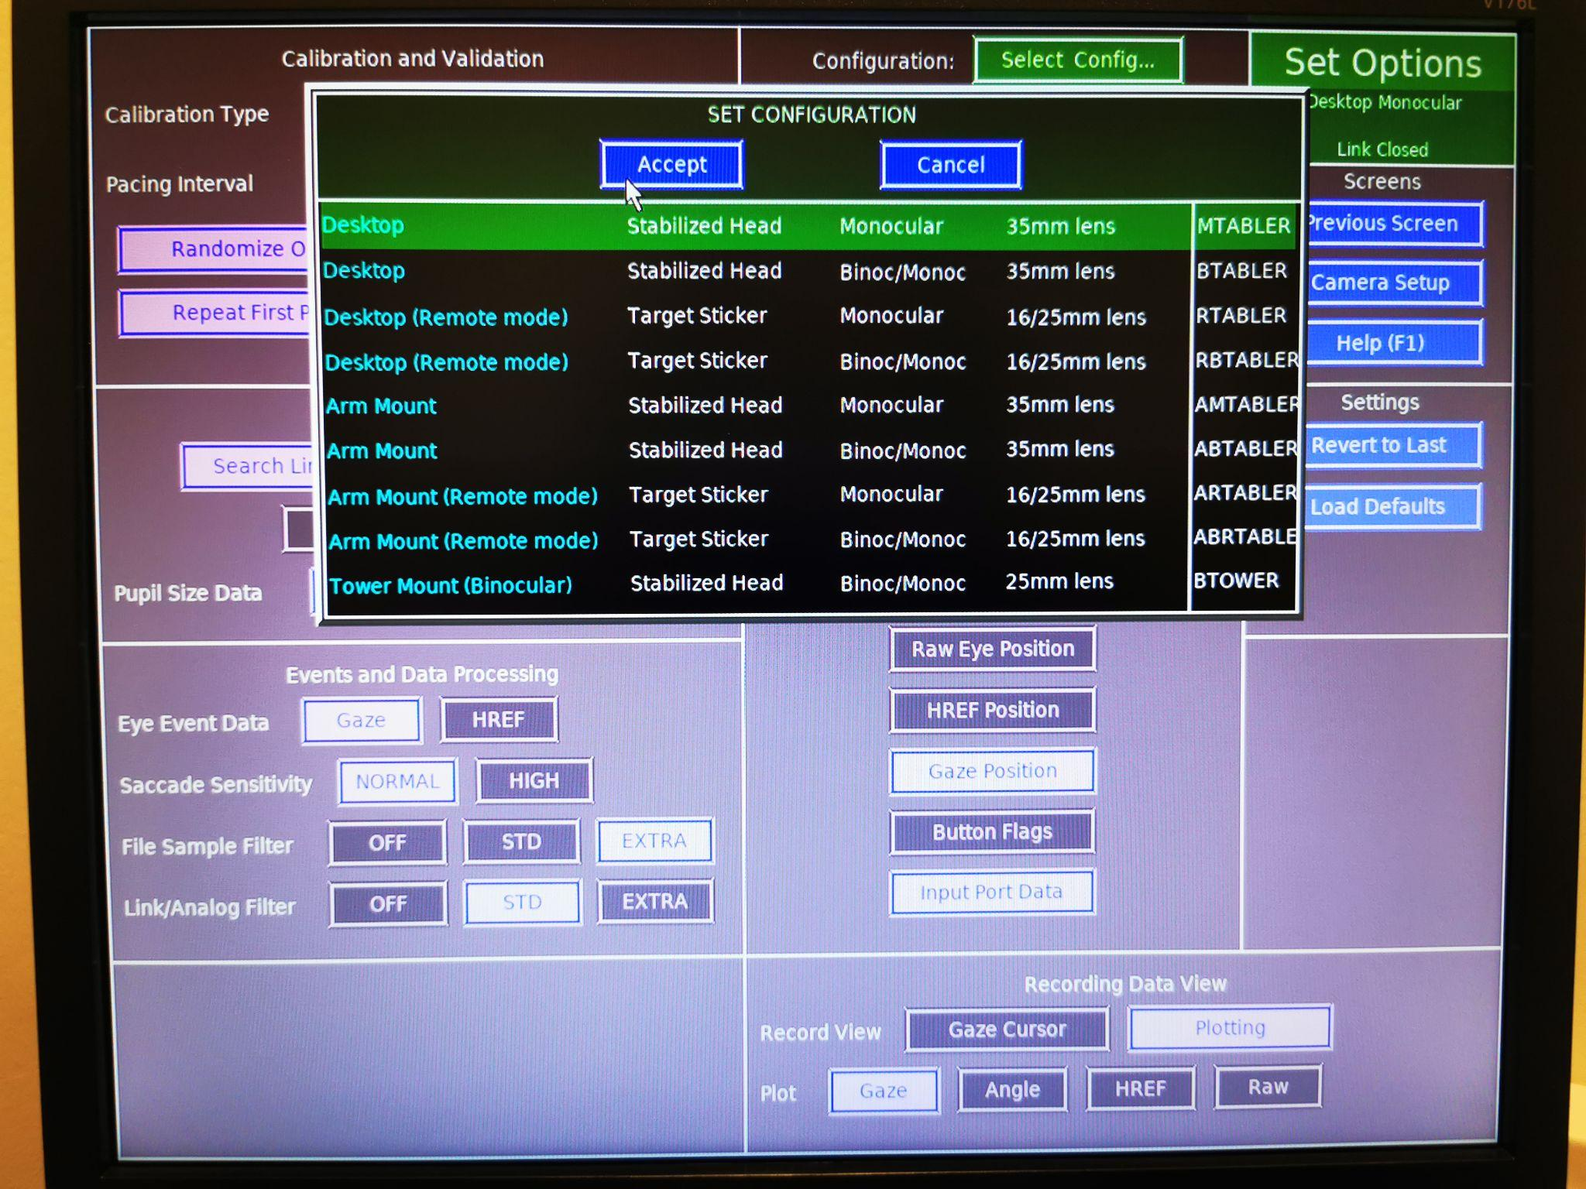
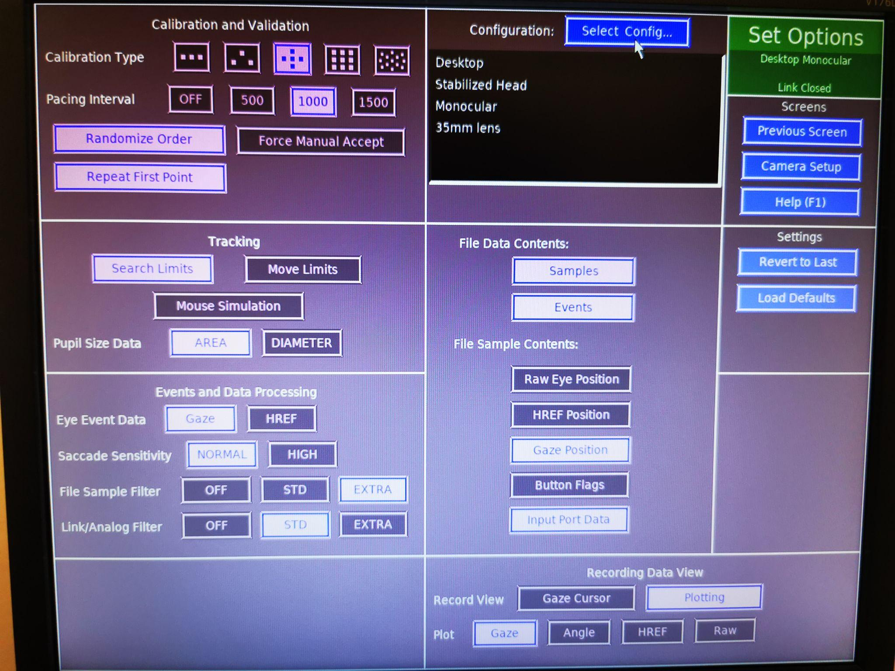
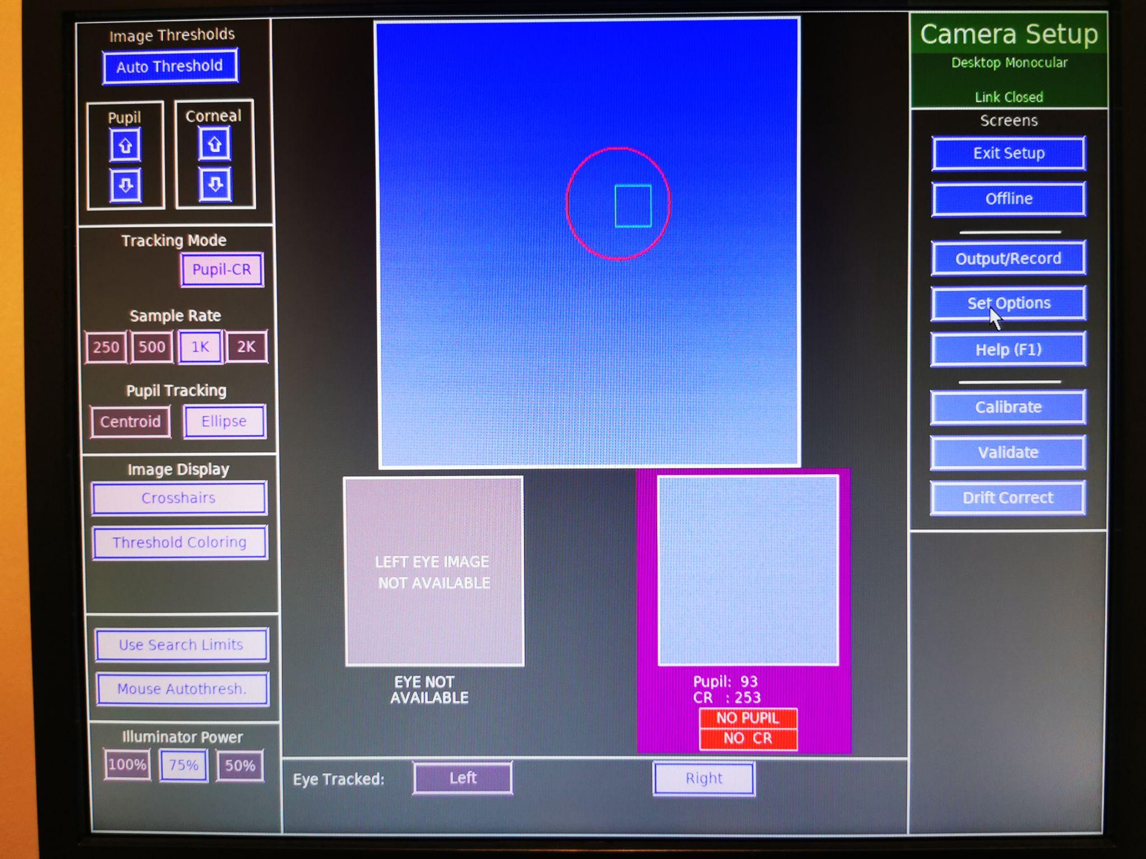

2. Intake
- Receive participant at ‘Participants waiting area’, bring to experiment room.
- Ask if needs to go to toilet. Toilet is down the hallway.
- If sleepy, offer coffee (espresso! make it quick and avoid taking it into the lab).
- Let participant turn phone off and put away.
- Give a short explanation of the experiment: Information letter/consent, application stimulators and calibration eye trackers, questionnaire, experiment is about 45-50 minutes including breaks. Total duration ~2 hours. Questions?
- Let participant read information letter and fill in informed consent and screening

3. Eye tracker and chin rest set up
3.1 Chin rest set up

- To check the eye position in the camera without running the experiment scripts in Python, run the script eyelink_setup.py found in: D:/Users/Olympia/tracking_touch_exp2/experiment2
- Ask to adjust the chair or chin rest so face of participant is aligned with chin rest → NB don’t adjust chair while chin is on rest!!!
- Try to get the RIGHT eye centered in the eye tracker screen (look at the eye-tracking computer in the control room if necessary)

3.1 Eye-tracker (prelim) set up

- Push ENTER (twice) to get to the eye-tracker options
- Click on the left or right arrows to enlarge or zoom in the image
- Choose the image where you can see most of the face (not zoomed in yet).
- Adjust the eye tracker manually in the experiment room (if necessary) by moving it around slightly without touching the lens or the infrared lights: You want the RIGHT pupil to be mostly centered on the screen. Click on the RIGHT eye with the mouse.
  - It is better to move the chair than the camera if possible!
- Type “A” for auto-adjust (you can do this as many times as necessary)
- Zoom in by clicking the right arrow
- Sharpen image by turning the lens. The little blue circle that appears around the pupil should be as small as possible.
- Type ESC to exit the setup script.

4. Application stimulators
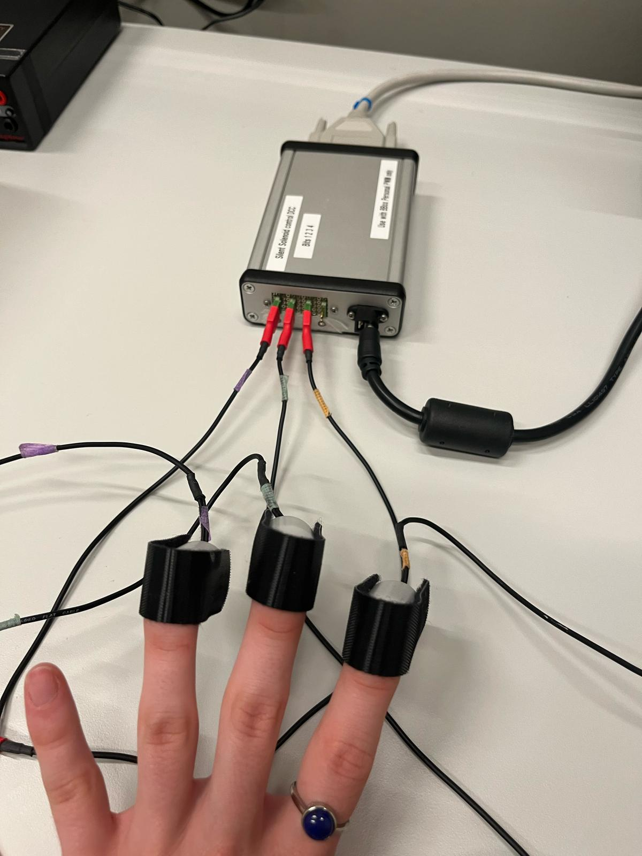
4.1. Solenoid placement
- Ask participant to turn their hand, the palm of their hand facing down
- Ask to apply solenoids
- Apply solenoid nº1 (see picture above/tape on box for numbers) on index finger with the velcro around the nail, and the cable facing outwards
- Secure velcro, ask if alright (not too tight)
- Repeat for the second selenoid on the middle finger and third selenoid on ring finger
- Ask participant to let hand rest on pillow facing up/down depending on participant number* before beginning of the task
  - ** Starting hand position will depend on whether the participant's number is even or odd. (This is coded into the program and will be determined automatically)
    - Even → Up
    - Odd → Down

5. Practice
- Start Practice rounds by opening the script in PsychoPy 2024.2.4
D:/Users/Olympia/tracking_touch_exp2/experiment2/touch_prediction_PRACTICE_version2.py
- Tell the participant that during the practice round they will receive stimulation on the same finger twice, just to get used to the sequence and icons. There are no predictions yet. Tell participant this takes about 5-10 minutes. Show the participant the sequence figure.
- Run the script
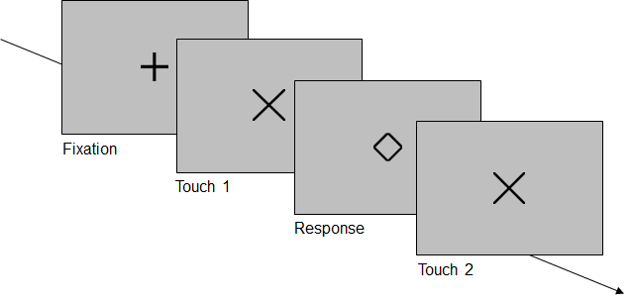

6. Experiment
6.1. Before starting the script
- NB Check the correct participant number to enter into the scripts!
- Open script in PsychoPy 2024.2.4:
  - D:/Users/Olympia/tracking_touch_exp2/experiment2/ touch_prediction_version2.py
- Tell the participant: “Now the actual experiment will begin. You will try to predict the finger of the second touch (arrows) based on the first touch. There will be 9-10 blocks in total, each with several trials. In between the blocks, you can take a break to move your head. After each break, I will do a short drift correction, so the eye tracker will maintain fixation on your pupil. During the trials, try to keep your eye fixated on the icons on the screen. You can blink as you normally would, but try to keep your head steady. This part will take about 45-50 minutes. Do you have any questions?”
- “We will first calibrate the eye tracker” → (First few steps have been set up already, but go over them to double-check)
- Place headphones
- Run the script
- Push ENTER to get to the eye-tracker options
- Adjust the eye tracker manually if needed. Click on the RIGHT eye with the mouse.
- Type “A” for auto-adjust (you can do this as many times as necessary)
- Sharpen image by turning the lens. The little blue circle that appears around the pupil should be as small as possible
- Type “C” for ‘calibrate’ on Eye Link computer or on the stimulus computer. You might have to start it by pressing the SPACE bar.
- Tell the participant to follow the changing dots on screen, but not to anticipate them. They have to rest their eyes on the dots and only after the dot has shifted, move their eyes to the new location
- Type “V” for ‘valibrate’ on Eye Link computer or on the stimulus computer. You might have to start it by pressing the SPACE bar.
- Check the validation on the EyeLink computer. It should say “good” (green). If so, click “Accept” from the EyeLink computer. If not, then try again by starting over with “C” calibration.
- Type “ESC” to exit the EyeLink mode and start the rest of the experiment. The instructions should appear.
- The participant can start the experiment by pressing any button until it breaks automatically (every 21 trials).
- Tell the participant they can move their head and hand during the break.

6.2. After breaks: Do drift correction
- After a break, it will be necessary to do a drift correction for the eye position. You can do this by clicking the button ‘Drift correction/check’ on the Eye Link computer in the control room. The participant just needs to put their head back on the chin rest and fixate.
- Click “Accept” on the EyeLink computer when you can see they are fixating the cross.
- Type ESC on the stimulus computer to exit the EyeLink mode in the script. (The EyeLink should immediately start recording again).
- The experiment immediately continues after this.

6.3. After the experiment
- Go into the experiment room with the participant
- Ask participant to carefully remove solenoids
- Ask participant probabilities questionnaire (on paper) → After ask if they knew the probabilities
- Ask participant to fill out AQ questionnaire
  - Dutch: https://questions.socsci.ru.nl/index.php/664839?lang=nl
  - English: https://questions.socsci.ru.nl/index.php/245395?lang=nl
  - These links can also be found here:
    - D:/Users/Olympia/tracking_touch_exp2/experiment2/ AQ questionnaire links.txt

Troubleshooting:
- To prematurely stop the task press <Q> or <ESC>. Keep doing this until it stops!

7. Debriefing
- Tell the participant the experiment is finished and ask if they have any questions. Tell them the following:
o “With this task are looking at prediction errors. These occur the moment your prediction about where the second touch would be is violated and show that the brain makes calculations/predictions. We want to see if these tactile prediction errors are seen in how much the pupil dilates and thus also measured your pupil.”
- If curious, it is fine at this point to tell them the actual pattern was and if what they wrote down was correct or not.
- Payment: fill in full name or SONA ID for credit in participant list and get signature) → give gift card
- Show participants the way out.

8. Afterwards
8.1. After each participant
- Fill in logbook (Logbook.xlsx)
o Date and time
o Assigned participant number
o Any particularities. Note all deviations from the protocol. If everything went according to protocol, write that there were no particularities.
- Set everything back up for next participant
8.2. After each testing day
- Close all software
- Save and backup data on DAC: https://data.ru.nl/login
- Remove all cables and put the solenoid equipment back in the box in the control room
- Remove the power cord of the eye tracker and put the cap back on the lens
- Shut down the Eye Link and task computer (“Exit EyeLink” then once it is in terminal mode, just push the power button to turn it off)
- Turn off the lights (green button for equipment, separate button for light in control room).
- If participants participated for SONA credits, assign these to them.
- Return the lab key



